Database

* What is Database?
* In computing, a database is an organized collection of data stored and accessed electronically. Small databases can be stored on a file system, while large databases are hosted on computer clusters or cloud storage
* What is RDBMS?
* An RDBMS is **a type of database management system (DBMS) that stores data in a row-based table structure which connects related data elements**. An RDBMS includes functions that maintain the security, accuracy, integrity and consistency of the data. Example - SQL
* What is Distributed Database?
* A distributed database is a database in which data is stored across different physical locations. It may be stored in multiple computers located in the same physical location; or maybe dispersed over a network of interconnected computers. Example – NoSQL
* List of Top SQL Databases:
* Microsoft SQL
* MySQL
* PostgreSQL
* OrientDB
* MariaDB
* List of Top NoSQL Databases:
* MongoDB
* Apache Cassandra
* Apache HBase
* Apache CouchDB
* Neo4j
* RavenDB
* Redis
* OrientDB

ACID Properties for SQL:

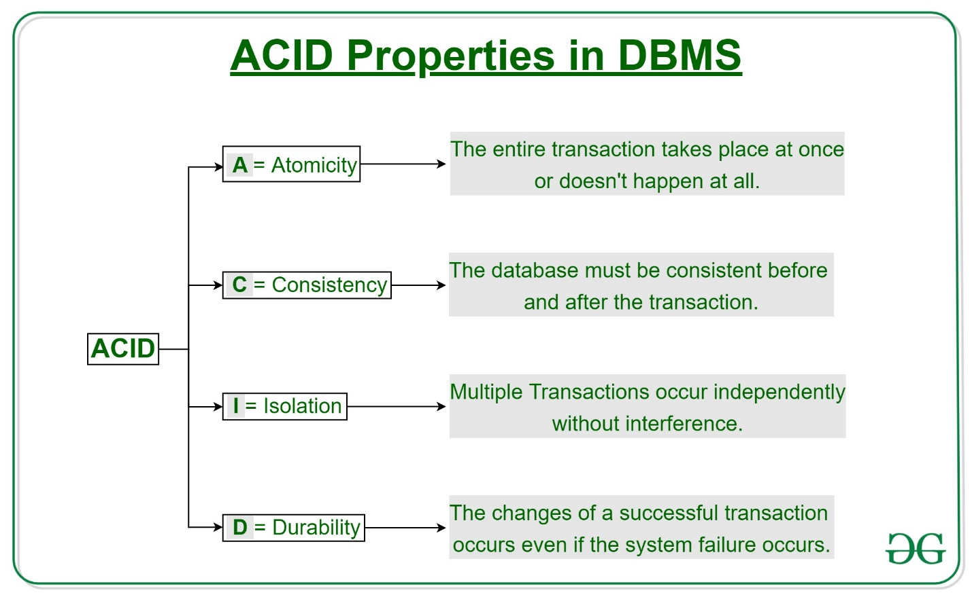

CAP Properties for NoSQL:

